Create and design a HTML page for Student registration. Form contains data like

Student Name (Text box): should contain 5 to 20 characters. Should have one Uppercase letter.

Password (Text Box) : Should contains 1 to 10 characters + Alpha Numeric+ Minimum one special Character and One Uppercase should.

Student age ( Text box) : Should accept only numeric

Gender (radio button ) : male or female

Subject taken: It should be checkboxes. Subjects are Computer science, Physics, Chemestry, Mathematics, English. ( out of the 5 subject 2 are mandatory). If user selects one checkbox and clicks on submit button appropriate error message should show.

Once the input data is successfully validated user can move to next HTML screen by clicking on a Submit button. Design the page with CSS.

Skill:

HTML

CSS

JavaScript

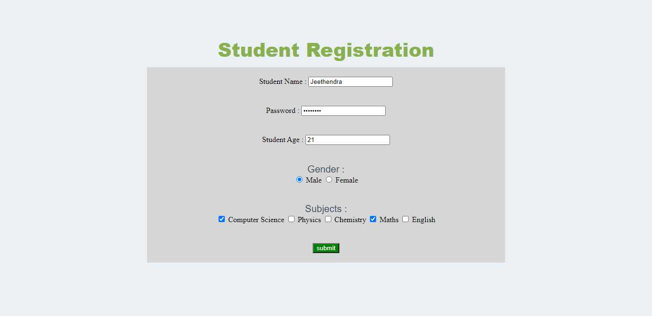

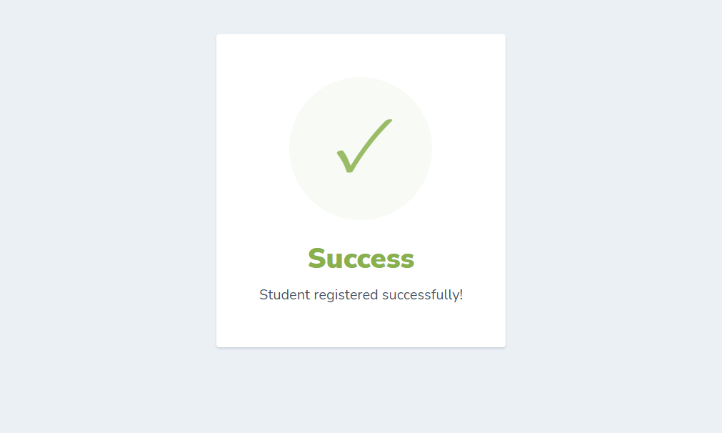

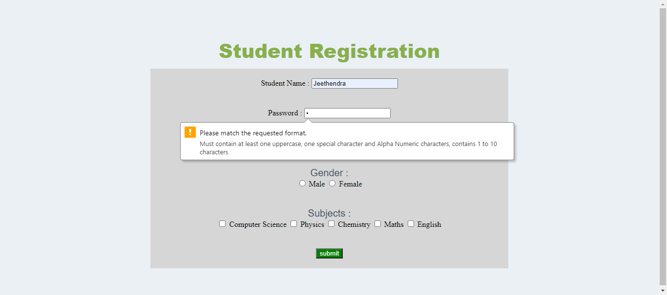

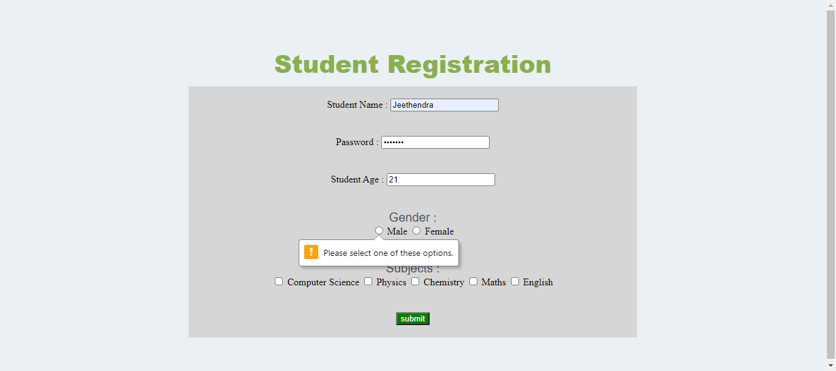

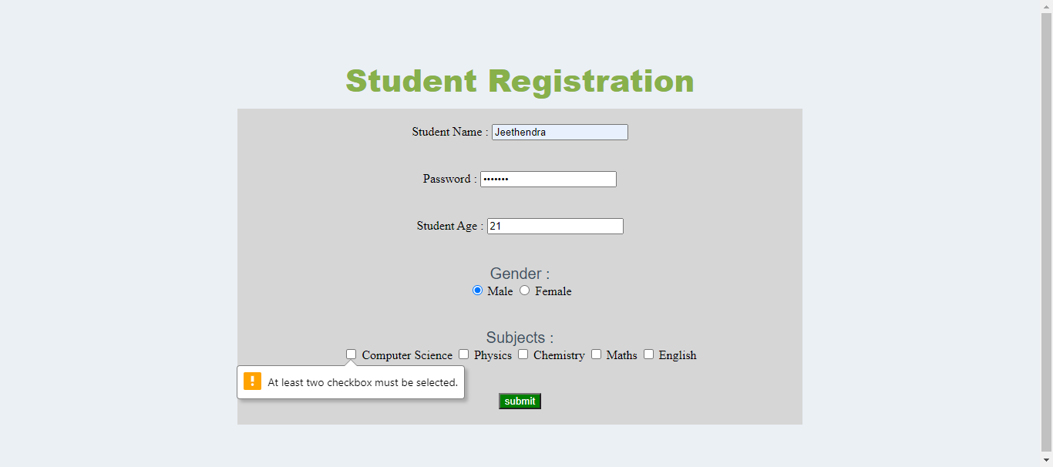

# Index.html

<!DOCTYPE html>

<html lang="en">

<head>

    <meta charset="UTF-8">

    <meta http-equiv="X-UA-Compatible" content="IE=edge">

    <meta name="viewport" content="width=device-width, initial-scale=1.0">

    <title>Milestone assessment 2</title>

    <link rel="stylesheet" href="style.css">

</head>

<body>

    <h1>Student Registration</h1>

    <form action="success.html" id="sectionForm">

        <div class="boxContainer">

            <label for="student_name">Student Name : </label>

            <input type="text" id="student_name" name="student_name" minlength="5" maxlength="20">

        </div>

        <div class="boxContainer">

            <label for="password">Password : </label>

            <input type="password" name="password" id="password" minlength="1" maxlength="10"

                pattern="(?=.*[A-Z])(?=.*[@$!%*?&])[A-Za-z\d@$!%*?&]{1,10}$"

                title="Must contain at least one uppercase,  one special character and Alpha Numeric characters, contains 1 to 10 characters">

        </div>

        <div class="boxContainer">

            <label for="student_age">Student Age : </label>

            <input type="number" name="student_age" id="student_age" required>

        </div>

        <div class="boxContainer">

            <p>Gender : </p>

            <input type="radio" id="male" name="gender" value="Male" required>

            <label for="male">Male</label>

            <input type="radio" id="female" name="gender" value="Female" required>

            <label for="female">Female</label>

        </div>

        <div class="boxContainer">

            <p>Subjects : </p>

            <input type="checkbox" id="Computer_Science" name="Computer_Science" value="Computer_Science">

            <label for="Computer_Science"> Computer Science</label>

            <input type="checkbox" id="physics" name="physics" value="physics">

            <label for="physics"> Physics</label>

            <input type="checkbox" id="chemistry" name="chemistry" value="chemistry">

            <label for="chemistry"> Chemistry</label>

            <input type="checkbox" id="maths" name="maths" value="maths">

            <label for="maths"> Maths</label>

            <input type="checkbox" id="english" name="english" value="english">

            <label for="english"> English</label>

        </div>

        <div class="boxContainer">

            <input type="submit" value="submit" class="btn">

        </div>

    </form>

    <script>

        (function () {

            const form = document.querySelector('#sectionForm');

            const checkboxes = form.querySelectorAll('input[type=checkbox]');

            const checkboxLength = checkboxes.length;

            const firstCheckbox = checkboxLength > 1 ? checkboxes[0] : null;

            function init() {

                if (firstCheckbox) {

                    for (let i = 0; i < checkboxLength; i++) {

                        checkboxes[i].addEventListener('change', checkValidity);

                    }

                    checkValidity();

                }

            }

            function isChecked() {

                var ct = 0;

                for (let i = 0; i < checkboxLength; i++) {

                    if (checkboxes[i].checked) {

                        ct++;

                    }

                }

                return ct;

            }

            function checkValidity() {

                const errorMessage = isChecked() < 2 ? 'At least two checkbox must be selected.' : '';

                firstCheckbox.setCustomValidity(errorMessage);

            }

            init();

        })();

    </script>

</body>

</html>

#success.html

<html>

<head>

    <link href="https://fonts.googleapis.com/css?family=Nunito+Sans:400,400i,700,900&display=swap" rel="stylesheet">

    <link rel="stylesheet" href="style.css">

</head>

<body>

    <div class="card">

        <div style="border-radius:200px; height:200px; width:200px; background: #F8FAF5; margin:0 auto;">

            <i class="checkmark">✓</i>

        </div>

        <h1>Success</h1>

        <p>Student registered successfully!</p>

    </div>

</body>

</html>

#style.css

body {

  text-align: center;

  padding: 40px 0;

  background: #ebf0f5;

}

h1 {

  color: #88b04b;

  font-family: "Nunito Sans", "Helvetica Neue", sans-serif;

  font-weight: 900;

  font-size: 40px;

  margin-bottom: 10px;

}

p {

  color: #404f5e;

  font-family: "Nunito Sans", "Helvetica Neue", sans-serif;

  font-size: 20px;

  margin: 0;

}

i {

  color: #9abc66;

  font-size: 100px;

  line-height: 200px;

  margin-left: -15px;

}

.card {

  background: white;

  padding: 60px;

  border-radius: 4px;

  box-shadow: 0 2px 3px #c8d0d8;

  display: inline-block;

  margin: 0 auto;

}

.boxContainer {

  padding: 20px 20px;

}

#sectionForm {

  background-color: rgb(214, 214, 214);

  margin: 10px 300px;

}

.btn {

  background-color: green;

  color: white;

}